Software Project Management
CT 2 Important

Multiple Choice Type Questions
- Which model helps represent the flow of data in a system?
  - ER Diagram
⬛ b) Data Flow Diagram
- Use Case Diagram
- State Diagram

- The Data Dictionary is primarily used to:
⬛ a) Store metadata
- Store data values
- Define code modules
- Document errors

- What is the main goal of a Feasibility Study?
  - Determine cost of hardware
⬛ b) Evaluate system viability
- Write system code
- Test system quality

- Verification ensures that:
  - Software meets user needs
⬛ b) Software is built correctly
- Software is fully debugged
- Software is documented

- Black Box Testing is concerned with:
  - Logic of the program
⬛ b) Input/output behavior
- Source code structure
- Algorithm complexity

- System Integration Testing focuses on:
  - Testing individual units
⬛ b) Testing combined modules
- Testing database design
- Testing code efficiency

- Structured English is used to:
  - Model program flow
⬛ b) Describe logical procedures
- Write test cases
- Define entities

- A Decision Tree helps to:
  - Document design applications
⬛ b) Represent decision paths
- Create data models
- Test applications

- Validation ensures that:
⬛ a) Software meets user expectations
- Code follows standards
- All errors are fixed
- Documentation is complete

- What does SRS stand for in software engineering?
⬛ a) Software Requirement Specification
- System Review Sheet
- Software Resource Summary
- System Requirement Summary

- Which document defines the project scope and objectives?
  - Test Plan
⬛ b) Project Charter
- Design Document
- Feasibility Report

- Which testing method examines internal logic and structure?
  - Black Box Testing
  - Regression Testing
⬛ c) White Box Testing
d) Load Testing

- The primary goal of Software Quality Assurance is to:
  - Detect bugs
  - Improve reliability
⬛ c) Ensure process quality
d) Increase performance

- Which model is most suitable when requirements are unclear?
  - Waterfall Model
  - Spiral Model
  - V-Model
⬛ d) Prototype Model

- Which term describes the process of combining modules to form a complete system?
  - Coding
⬛ b) Integration

- Validation
- Deployment

- In project management, Gantt Charts are used for:
  - Testing
⬛ b) Scheduling
- Cost estimation
- Risk assessment

Question Answers

Explain the significance of Data Flow Diagrams (DFDs) in system analysis.
  - DFDs show how data moves through a system.
  - They help understand the input, process, and output of data.
  - DFDs help in finding errors and improving system design.
  - They make communication between users and developers easier.
  - Useful for both designing and documenting systems.

What are the main components of a Feasibility Study?
  - Technical Feasibility: Can the system be built with available technology?
  - Economic Feasibility: Is the project cost-effective and profitable?
  - Operational Feasibility: Will the system work well in the real environment?
  - Legal Feasibility: Does it follow laws and regulations?
  - Schedule Feasibility: Can it be completed on time?

Define Structured English and mention its advantages.
  - Structured English is a way of writing logic using simple English and programming keywords like IF, THEN, ELSE.
  - Advantages:
  - 1. Easy to understand for both technical and non-technical people.
  - 2. Reduces confusion and mistakes.
  - 3. Helps convert logic into code easily.
  - 4. Useful for documenting business rules.

Describe the purpose of Decision Tables in software project management.
  - Decision tables show rules for making decisions based on different conditions.
  - They help handle complex logic clearly.
  - Reduce errors and misunderstandings.
  - Useful in testing and validation of business rules.

Differentiate between Verification and Validation.
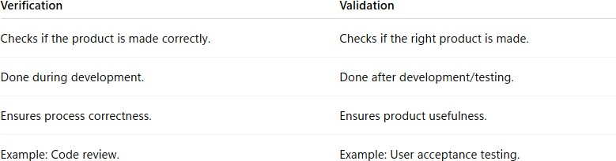

- Define System Testing and state its importance.
  - System testing checks the complete system as a whole.
  - It ensures all parts work together properly.
  - Detects errors missed in earlier tests.
  - Verifies that the system meets all requirements.
  - Helps deliver a reliable final product.

What is the role of a Software Requirement Specification (SRS)?
  - SRS is a detailed written document of what a software should do.
  - It defines all functional and non-functional requirements.
  - Acts as a guide for developers, testers, and clients.
  - Reduces misunderstanding and rework.
  - Helps in project planning and validation.

Explain the difference between Black Box and White Box Testing.
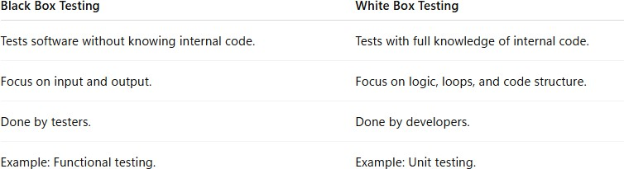

- What is the importance of project scheduling in software development?
  - Helps plan and organize project tasks.
  - Ensures work is completed on time.
  - Identifies resource and manpower needs.
  - Helps track progress and avoid delays.
  - Improves team coordination and efficiency.

Define Software Quality Assurance (SQA) and list its major activities.
  - SQA ensures software meets quality standards and prevents problems instead of just finding them.

Major Activities:
    - Process planning and audits.
    - Reviews and testing.
    - Error prevention and correction.
    - Quality measurement and improvement.

What is a prototype model and when is it used?
  - The prototype model builds a sample version of software before making the final one.
  - Helps users see and give feedback early.
  - Used when requirements are unclear.
  - Saves time by reducing rework later.
  - Useful in systems needing user interaction.

Write short notes on Integration Testing.
  - Integration testing checks how modules work together.
  - It ensures data flow between modules is correct.
  - Finds interface and communication errors early.
  - Can be done using top-down or bottom-up approach.
  - Ensures the complete system works as expected.

